Estella, Anthony Lawrence –

[CPE 028-CPE41S1](https://tip.instructure.com/courses/23060)

Final Case Study | Network Automation and Programmability

I created a case study that used the Implementation of REST APIs with an SDN Controller and the Construction of a Python Script to Manage Webex Teams.

* Through this case study, I used the Packet Tracer Network Controller and associated API documentation to send REST request from Postman and Visual Studio Code (VS Code). Packet Tracer also supports a Python coding environment.
* Another part of this case study used Webex Teams APIs to authenticate, manage people, manage rooms, manage memberships to rooms, and send a message.

This study focused on Network Programmability.

Here are the screenshots.

1. IMPLEMENTATION OF REST APIs WITH AN SDN CONTROLLER

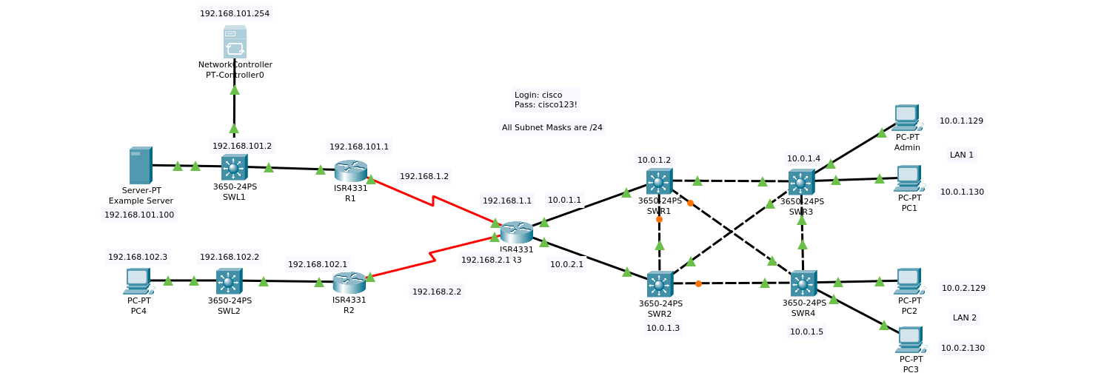

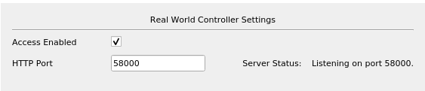

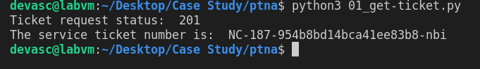

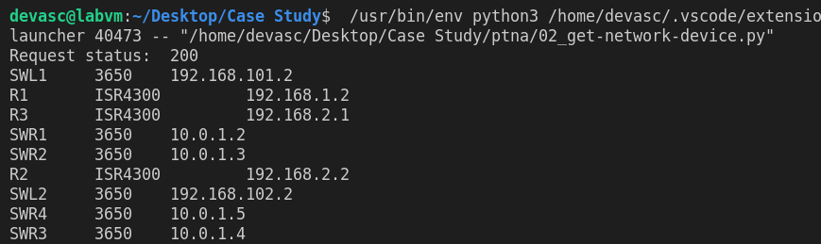

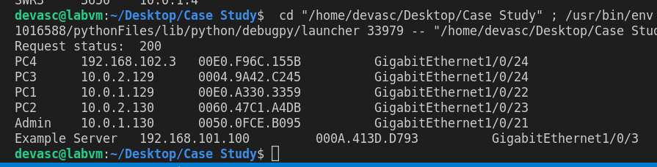

1. Construction of a Python Script to Manage Webex Teams.

